Errata: Regression Trees Video
This errata clarifies two inaccuracies in the “Regression Trees” video to ensure conceptual alignment with regression tree methodology.
1. Between 01:26 and 01:39, the transcript and on-screen text incorrectly refer to “classes” in the context of regression trees.
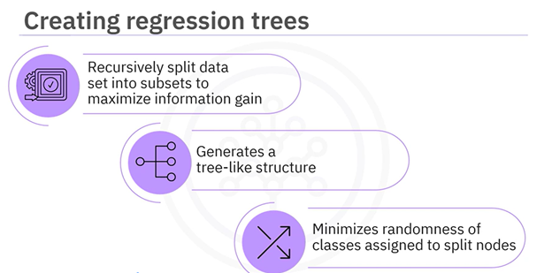
The video currently states:
“Regression trees are created by recursively splitting the dataset into subsets to maximize information gained from data splitting. This process generates a tree-like structure and minimizes the randomness of the classes assigned to the split nodes.”
This is inaccurate since the term “classes” applies to classification trees, not regression trees.
The corrected statement should be read as follows:
“Regression trees are created by recursively splitting the dataset into subsets to minimize the variance or Mean Squared Error (MSE) of the target values. This process generates a tree-like structure and reduces the spread of the predicted values within each node.”
2. Between 04:09 and 04:20, the transcript and on-screen text incorrectly reference classification strategies (“one-versus-one” and “one-versus-all”) in the context of regression trees.
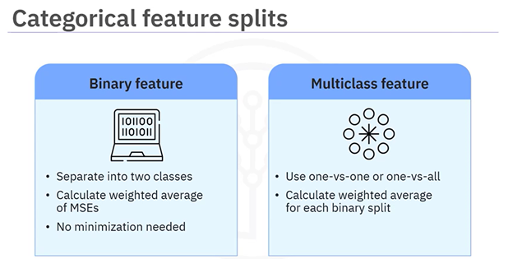
The video currently states:
“For a multi-class feature, you can use a strategy like one-versus-one or one-versus-all to generate a set of possible binary splits.”
This phrasing is inaccurate, as such strategies apply to classification problems, not regression trees.
The corrected statement should be read as follows:
“For categorical features with multiple levels, evaluate different binary partitions of the categories and select the split that minimizes the weighted MSE.”

